HABITS OF A MULTIPLYING DISCIPLE: FIND

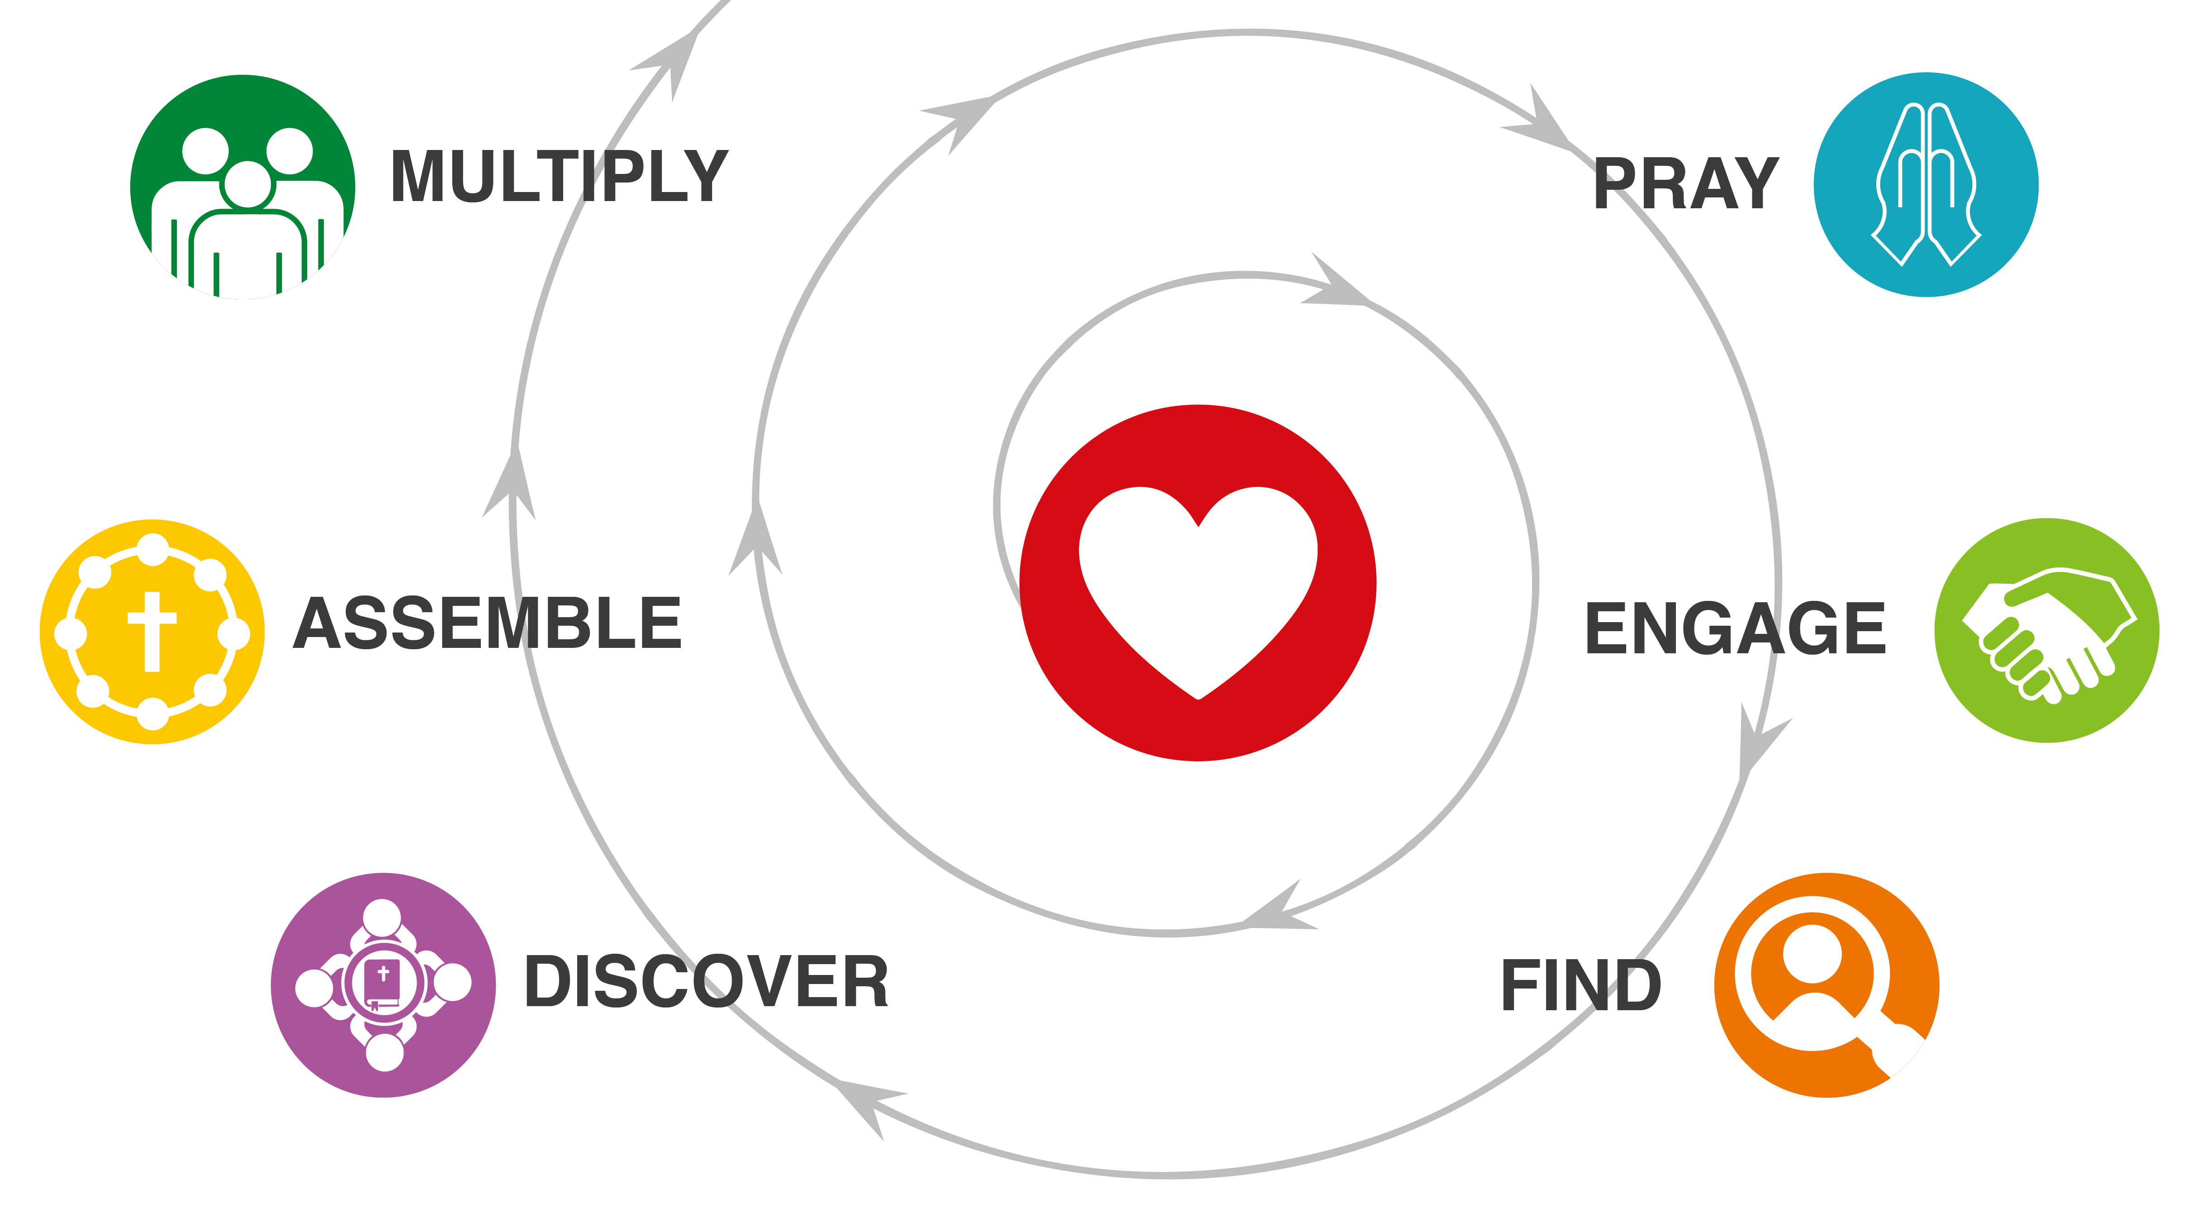
HOMEWORK DISCUSSION
How is it going completing your “I will’s”?
How did it go this week making daily “Shema” statements?
What did you learn when you asked 3 people about the greatest needs in your community?

FINDING PERSONS OF PEACE
Read the Luke 10:1-11 aloud. Matt. 9:35-10:16
Make 2 Lists…
- What did Jesus tell his followers to do?
- What are the characteristics of a person of peace?

OTHER EXAMPLES OF PERSONS OF PEACE
Brainstorm together:
- What other examples of persons of peace can you think of in the Bible?
Consider your own lives and experiences:
- Were you a person of peace?
- Or were you influenced to follow Christ by a person of peace?
- In your own experience, when have you seen persons of peace bring others to Jesus?

ADOPTING A NEW APPROACH TO REACHING OTHERS
How does the “Person of Peace” strategy differ from traditional approaches to reaching others? Make a list of contrasts as a group.

Using simple stick figures, illustrate how the two different approaches work.

YOUR ASSIGNMENT
- Do a 3-Column Study on John 6:44-46
- Probe spiritual openness with at least 2 people this week. If it helps, tell the person that it is part of an assignment you have for a class on experiencing God.
  - Ask them, “Where are you at in your spiritual journey?”
  - Or ask, “If you could ask God for one miracle right now, what would it be?” Then say a simple pray for them.

What does it say?
(Write the text word-for-word.)

What does it mean?
(Write it in my own words.)

What must I do to obey?
(My “I will…” statement.)

With whom will I share?

